1. Create project like the following figure:

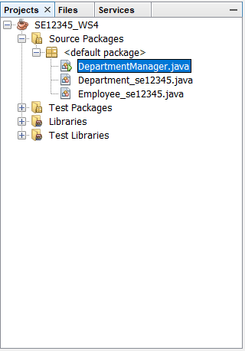

1. Create file like the following figure:

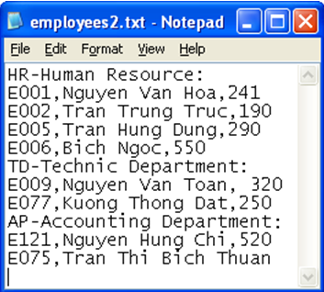

1. Design the GUI like the following figure**(10 marks)**

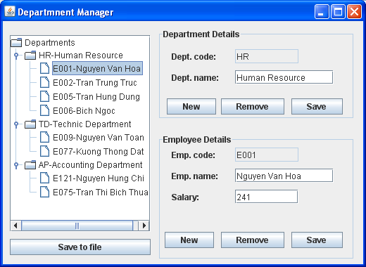

Performance requirements:

* Read data from file to Jtree.
* Button New (Department) : Enter a new department.
* Button Remove : Remove cuurent department.
* Button Save : Display new department on the Jtree.
* Button New : Enter a new employee.
* Button Remove : Remove cuurent employee.
* Button Save : Display new employee on Jtree.
* Button Save To File : Write the Department and the employee list to File.